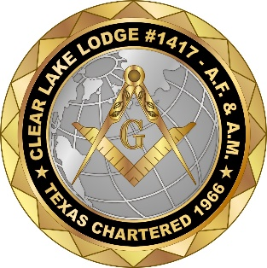
The Trestle Board
April 20, 2026
Clear Lake Masonic Lodge #1417
Our Misson;
“Recognize, Accept, and Educate Men of Good Quality”
Worshipful Master RW Alan E. Duncan
Secretary: Thomas G. Merchant
Phone 281-682-3670
Lodge Email: secretaryclearlake1417@gmail.com
Mail & Street Address: 1707 Les Talley, El Lago 77586
Stated Meeting: 2nd Tuesday of Every Month
Dinner 6:15 p.m. - Meeting at 7 p.m.

Master Masons Visit Our Closed FB Page “CLL#1417”
And
Like us at Our Public Page “Clear Lake Lodge #1417”
Also
Check Out Our New Web-Site for the
Clear Lake Masonic Library & Museum Foundation

Lodge Brothers cooking at the El Lago city Celebration April 18th was a big success thanks to chief cooks Brothers Patric O’Neal and Robert Kumar-Misir assisted by a food distribution crew of Craig, Neubauer and Jerry Carpenter.

Brother Calvin Wolff has updated the Lodge webpage “clearlakemasons.org” it is still being updated by Brother Wolff and currently consists of a home section show photos of the building, a section for Lodge Trestles and a virtual library. As you look it over give feedback to Brother Wolff.

April Activities
(Tuesday Unless Otherwise Noted)

- Tonight Monday the 20th “Officer School of Instruction”
- The 21st Cornhole tournaments, at Boondoggles registration at 6:00pm
- Monday the 27th “Officer School of Instruction”
- The 28th Cornhole tournaments same place and time as above

May Activities
(Tuesdays Unless Otherwise Noted)

- Saturday May 2nd Lodge Instruction For Effectiveness(LIFE) will be taught at the Lodge starting at 8:00am please RSVP if you want to attend please contact Brother Secretary.
- Monday May 4th Services for Brother Mitzner, details sent in a special Trestle
- May 5th Cornhole tournaments
- Monday the 11th “Officer School of Instruction”
- May 12th Stated Meeting
- Monday May 18th “Officer School of Instruction”
- May 19th Lamar Medal presentation at Ed White Elementary and Cornhole tournaments
- May 26th Cornhole tournaments

Education Thought

“Within the quiet chamber of the Lodge,
A Mason learns that the truest work is not laid in stone,
But in the steady shaping of his own character;
Square in virtue;
Level in Humanity;
And Upright before all”.

The Quiz

“In appearance an object of metal, confined for one simple task, Masons use a symbol of silence.”

What It?

As always send your answer to secretaryclearlake1417@gmail.com

Weekly Verse
Psalm 105
“O give thanks unto the Lord; call upon His name; make know His deeds among the people.”

